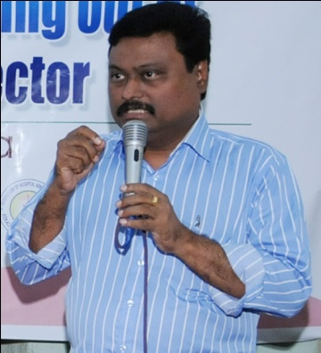

**Dr. C. Suresh Kumar**

Dr.C.Suresh Kumar is a leading pediatrician in Kerala Health Department and a medical doctor with impeccable orientation for social action.

He was one of the founder team members of Swadeshi Science Movement (SSM) and the organization expanded its activities into various scientific arenas during his tenure as General Secretary. He also served as the editor of the Malayalam Science Magazine of SSM, “Swadeshi Science”. Dr.Suresh led the first massive awareness campaign in Kerala to raise awareness about the need for conservation of rivers- Nadi Vandanam in the year 2000. In SSM Dr.Suresh served as the Chief Coordinator of the land mark event first World Ayurveda Congress (WAC) at Kochi in 2002,where representatives from 27 countries participated.

Dr.Suresh, along with fellow medical practitioners, scientists and social workers founded Centre for Innovation in Science and Social Action (CISSA) in 2006. While continuing as the General Secretary of CISSA, Dr.Suresh envisaged multi-layered activities that have percolated into the grass roots and some of the programmes in this stream included ANNAM -Good Food Movement( a movement for food security, food sovereignty and good food culture.), URJA (Movement to popularize energy efficient gadgets), Global Ayurveda Festival-Kerala (to highlight the importance of traditional Ayurveda practice of Kerala and to bring it into global focus) and Indian Biodiversity Congress (to serve as platform to propose alternate strategies for biodiversity conservation). Some of the other activities initiated under his leadership include Lightning Awareness and Research Centre, Shreshta Krishi a movement for organic and sustainable agriculture.